**Create a site column in a list or library**

1. On the home page, select **Settings**  Settings button from SharePoint Online, and then select **Site Settings**. If you don't see **Site settings**, select **Site information,** and then select **View all site settings**. Some pages might require you to select **Site contents**, and then **Site settings**.
2. On the **Site Settings** page, under **Web Designer Galleries**, select **Site columns**.
3. On the **Site Columns** page, select **Create**.
4. In the **Name and Type** section, enter the name that you want in the **Column name** box.
5. Select the type of information you want to store in the column. To learn more, see [Site column types and options](https://support.microsoft.com/en-us/office/list-and-library-column-types-and-options-0d8ddb7b-7dc7-414d-a283-ee9dca891df7).
6. In the **Group** section, select the existing group in which to store the new site column, or create a new group to store the column.

The list of **Existing groups** can vary with the version of SharePoint, and what groups have been added.

1. In the **Additional Column Settings**section, select the additional column settings you want. The options available in this section differ depending on the type of column that you select in the **Name and Type** section.
2. Select **OK**.
3. Navigate to the list or library you want to create a column in.

If the name of your list or library does not appear on a page, select **Settings**  SharePoint 2016 Settings button on title bar. >**Site Contents**, and then select the name of your list or library.

1. Select **Settings**  SharePoint 2016 Settings button on title bar. > **List settings** or **Library settings**. Depending on your SharePoint version, you may need to select **More library settings**.
2. On the **Settings** page, scroll down to the **Columns** section, and then select **Add from existing site columns**.
3. On the **Add Columns from Site Columns** page, in the **Select Columns** section, select the group of site columns to choose from in the **Select site columns from** dropdown.

When you select a column group from the list, the available site columns appear in the **Available site columns** list.

**Note:**The Available site column list defaults to All Groups, but you can narrow the number of fields by choosing groups that may contain what you're looking for (for example, Core Document Columns or Custom Columns).

1. Select the site columns you want to add, and select **Add**. The columns appear in the **Columns to add** list box. To add the column to the default view, which people on your site automatically see when they first open a list or library, make sure **Add to default view** is selected. Some lists such as the Tasks list also have the option **Add to all content types**, which is selected by default. If you want to add the column to all content types, make sure **Add to all content types** remains selected.

Depending on the type list or library, there may be more settings in the **Options** section. Select the additional options that you want.

1. To save, select **OK**.
2. Go to the list or library that you want to delete a column from.

Or from a SharePoint site, select **Settings** Settings button from SharePoint Online, **Site Contents**, and then select the name of your list or library.

1. Select the column header for the column that you want to delete, and from the menu, select **Column settings** > **Edit**.

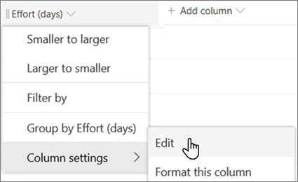

1. At the bottom of the Edit Column pane, select **Delete.**
2. To delete the column and the data in the column permanently, select **Delete**.